What is CSS?

Cascading style sheets (css) is the code that styles web content.

It is a style sheet language that is used selectively to style HTML elements for example text color

It can be used to define styles for your web pages, including the design, layout and variations in display for different devices and screen sizes.

Benefits of CSS

1. Solved a big problem because HTML was NEVER intended to contain tags for formatting a web page rather created to describe the content of a web page Therefore CSS removed the style formatting from the HTML page
2. Saves a lot of work because style definitions are normally saved in external.css files. With an external style sheet file, you can change the look of an entire website by changing just one file!

Anatomy of CSS

A CSS rule consists of a selector and a declaration block.

The selector points to the HTML element you want to style.

The declaration block contains one or more declarations separated by semicolons.

Each declaration includes a CSS property name and a value, separated by a colon.

Multiple CSS declarations are separated with semicolons, and declaration blocks are surrounded by curly braces.

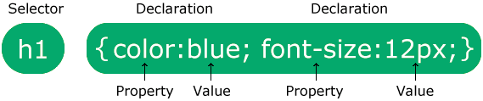

Summary

CSS stands for Cascading Style Sheets

CSS describes how HTML elements are to be displayed on screen, paper, or in other media

CSS saves a lot of work. It can control the layout of multiple web pages all at once

External style sheets are stored in CSS files